Task 3.

*1. Database Creation and Table Creation:*

sql

-- Create the "EventsManagement" database

CREATE DATABASE EventsManagement;

-- Connect to the database

\c EventsManagement;

-- Create tables for Events, Attendees, and Registrations

CREATE TABLE Events (

Event_id serial PRIMARY KEY,

Event_Name varchar(255),

Event_Date date,

Event_Location varchar(255),

Event_Description text

);

CREATE TABLE Attendees (

Attendee_id serial PRIMARY KEY,

Attendee_Name varchar(255),

Attendee_Phone varchar(15),

Attendee_Email varchar(255),

Attendee_City varchar(255)

);

CREATE TABLE Registrations (

Registration_id serial PRIMARY KEY,

Event_id int REFERENCES Events(Event_id),

Attendee_id int REFERENCES Attendees(Attendee_id),

Registration_Date date,

Registration_Amount numeric(10, 2)

);

INSERT INTO Events (Event_Name, Event_Date, Event_Location, Event_Description)

VALUES

('Diwali Celebration', '2023-11-04', 'Mumbai', 'Join us for a grand Diwali celebration!'),

('Tech Conference', '2023-12-15', 'Bengaluru', 'Explore the latest in technology and innovation.'),

('Cultural Festival', '2024-01-20', 'Jaipur', 'A colorful festival showcasing Indian culture and heritage.');

*Sample Data for Attendees:*

INSERT INTO Attendees (Attendee_Name, Attendee_Phone, Attendee_Email, Attendee_City)

VALUES

('Rajesh Kumar', '9876543210', 'rajesh@gmail.com', 'Delhi'),

('Priya Verma', '8765432109', 'priya@gmail.com', 'Mumbai'),

('Suresh Sharma', '7654321098', 'suresh@gmail.com', 'Chennai'),

('Amit Singh', '6543210987', 'amit@gmail.com', 'Bengaluru'),

('Neha Patel', '5432109876', 'neha@gmail.com', 'Ahmedabad');

-- Registrations for Diwali Celebration (Event with ID 1)

INSERT INTO Registrations (Event_id, Attendee_id, Registration_Date, Registration_Amount)

VALUES

(1, 1, '2023-11-02', 200.00),

(1, 2, '2023-11-03', 150.00),

(1, 3, '2023-11-04', 180.00);

-- Registrations for Tech Conference (Event with ID 2)

INSERT INTO Registrations (Event_id, Attendee_id, Registration_Date, Registration_Amount)

VALUES

(2, 4, '2023-12-10', 300.00),

(2, 5, '2023-12-11', 250.00);

-- Registrations for Cultural Festival (Event with ID 3)

INSERT INTO Registrations (Event_id, Attendee_id, Registration_Date, Registration_Amount)

VALUES

(3, 1, '2024-01-18', 100.00),

(3, 4, '2024-01-19', 120.00),

(3, 5, '2024-01-20', 150.00);

Task 4 3b

-- Example: Insert a new event

INSERT INTO Events (Event_Name, Event_Date, Event_Location, Event_Description)

VALUES ('New Year Party', '2023-12-31', 'Goa', 'Celebrate the New Year with us in Goa!');

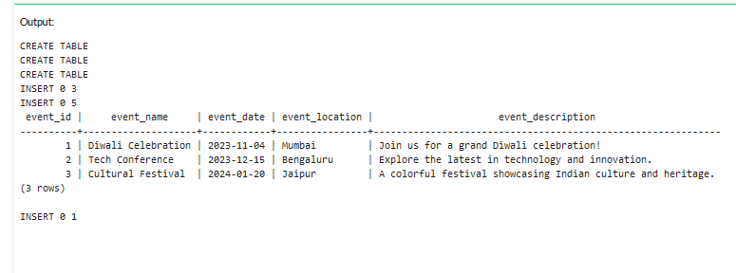

Task 4.3b

-- Example: Update event information (e.g., for event with ID 1)

UPDATE Events

SET Event_Name = 'Updated Event Name',

Event_Date = '2023-12-15',

Event_Location = 'Updated Location',

Event_Description = 'Updated event description'

WHERE Event_id = 1;

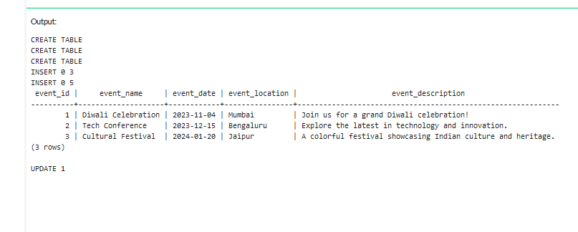

Task43c

-- Example: Delete an event (e.g., for event with ID 2)

DELETE FROM Events

WHERE Event_id = 2;

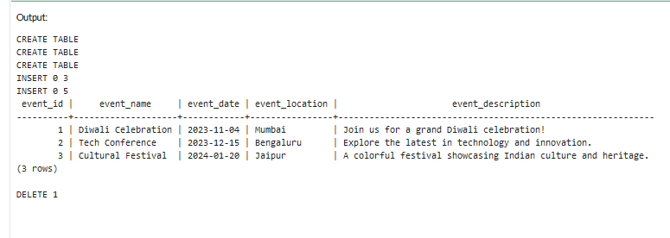

Task 4.4a

-- Example: Insert a new attendee

INSERT INTO Attendees (Attendee_Name, Attendee_Phone, Attendee_Email, Attendee_City)

VALUES ('New Attendee', '123-456-7890', 'new.attendee@example.com', 'New City');

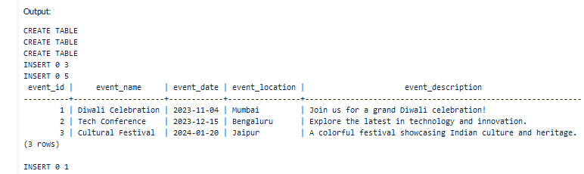

Task 4.4.b

-- Example: Register an attendee (e.g., Attendee with ID 1) for an event (e.g., Event with ID 1)

INSERT INTO Registrations (Event_id, Attendee_id, Registration_Date, Registration_Amount)

VALUES (1, 1, '2023-11-10', 50.00);

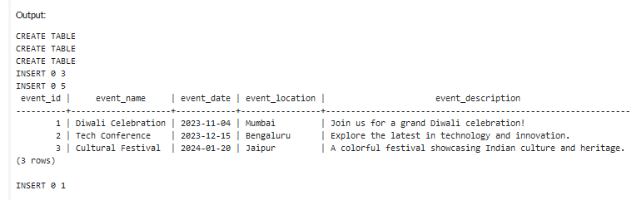

Task4.5

-- Retrieve event information (e.g., all events)

SELECT Event_id, Event_Name, Event_Date, Event_Location, Event_Description

FROM Events;

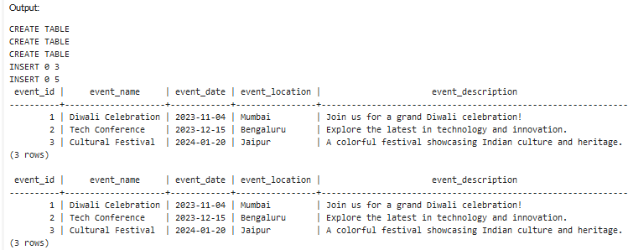

-- Generate an attendee list for a specific event (e.g., Event with ID 1)

SELECT A.Attendee_Name

FROM Attendees AS A

JOIN Registrations AS R ON A.Attendee_id = R.Attendee_id

WHERE R.Event_id = 1;

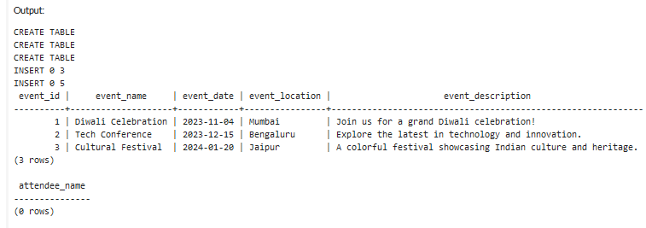

-- Calculate event attendance statistics (e.g., for Event with ID 1)

SELECT E.Event_Name,

COUNT(R.Attendee_id) AS Total_Attendees,

SUM(R.Registration_Amount) AS Total_Revenue

FROM Events AS E

LEFT JOIN Registrations AS R ON E.Event_id = R.Event_id

WHERE E.Event_id = 1

GROUP BY E.Event_Name;

